

Faculty of Technology
University of Sri Jayewardenepura

ITC 4172
Entrepreneurship and
Small Business Management
Assignment

Name: K.P.V.Perera
Index Number: ICT/21/897

AgroTech Solutions business Plan

1.Executive Summary

AgriTech Solutions is an online platform that helps farmers in Sri Lanka solve farming problems through technology. This platform allows farmers to get information on soil conditions, pest infestations, special fertilizer suggestions, market price information and cultivation advice. It operates as a mobile app and a website.
The business is based in Anuradhapura and will initially operate on a small scale, with the aim of expanding. The aim is to help farmers build an efficient, economical and modern farming system using information technology.
Our app provides farmers with an easy-to-use interface and provides them with information and advice based on the conditions of their farmland.

Objectives:
- Provide farmers with new technical knowledge
- Improve farm production
- Strengthen the relationship between farmers and the market
AgriTech Solutions is an innovative company that brings together technology and the agricultural sector, and our vision is to become a valuable intersection in the local farming sector in the future.

2. Company Description

2.1 Company History

- Business Name : AgroTech Solutions– Online Platform for Agricultural Problems
- Business Type: 100% Online IT-based Small Business
- Location: Anuradhapura, Sri Lanka
- Chairman : Mr. Pawan Vikasitha
- Founding Team: 3 Members (Roles: Technology, Content Development, Marketing)

Business Concept:
AgriTech Solutions is a platform that helps farmers solve their problems related to cultivation, fertilizer, water supply and pest infestation through online information and advice.

2.2 Vision, Mission Statement, Goals, Objectives, Strategies

Vision:
To raise Sri Lankan agriculture by empowering every farmer with accessible, affordable, and actionable technology solutions that enhance productivity, profitability, and sustainability.

Mission:
To provide a comprehensive digital platform that connects farmers with knowledge, markets, and resources and improve their livelihoods through innovative IT solutions fitted to local agricultural needs.

Goals (Next 1-3 Years)
- Onboard 10,000 active farmers at Western, Southern, and Central provinces within the first year.
- Establish partnerships with at least 100 agribusinesses, input suppliers, and agricultural cooperatives.

Objectives
- Launch fully functional mobile applications for Android and iOS within six months.
- Recruit a team of agricultural experts and data scientists to enhance platform capabilities.
- Implement multi-language support (Sinhala, Tamil, English) to reach diverse farming communities.
- Establish a 24/7 helpline for farmer support and emergency consultations in critical situations.

Core Values:
- Commitment to innovation and technology
- Providing efficient and convenient services to farmers
- Following the principles of trust and responsibility

Strategies
- Offer cost free basic services with premium tiers for advanced features to ensure accessibility
- Invest in continuous research and development to incorporate AI, machine learning, and IoT technologies.

2.3 Products and Services

Services provided by AgroTech:
- Information and advice on farming problems
Providing accurate advice on cultivation, fertilizer, pest infestation, water supply and other farming problems.

- Mobile App
Providing farmers with facilities such as crop management, weather information, disease prevention, market price information.
- Website
Providing a user-friendly user interface, FAQs, video advice, farmer chats and expert advice.
- Online Workshops and Seminars
Online webinars, practical guides, interactive sessions on modern farming methods.

2.4 Current Status

Primarily operating in Anuradhapura pilot stage, with plans for nationwide expansion in the future. . Early results show that crop disease losses have reduced by 50% among the users who actively use the disease diagnosis feature. We are currently developing user interfaces based on feedback and expanding our expert network.

2.5 Legal Status and Ownership

Our company is registered as a private limited company (Pvt Ltd), and the founding team shares technology, content/expert advice and marketing & communication responsibilities. Mr. Pawan Vikasitha acts as the Chairman.

2.6 Key Partnerships

We have ongoing partnerships with Government Department of Agriculture, NGO and technical partnership with local cloud hosting provider for infrastructure support.

3. Industry Analysis

Industry Size, Growth Rate, and Sales Projections

The agricultural technology sector in Sri Lanka is growing, and the demand for online farming solutions continues to increase. It is expected to grow at a rate of 15–20% annually, and there is a high demand for digital agriculture services in the future.

3.2 Industry structure
The industry consists of IT-based startups, digital service providers, and platforms that combine expert advice with data analytics.

  - Nature of participants

Participants such as startups, NGOs, agriculture consultants, tech developers are actively involved in this sector.

  - Key success factors

Accurate and timely advice, user-friendly interface, reliable expert content, and reasonable pricing are the key factors for success in this sector.

  - Industry trends

Increasing use of mobile apps among farmers, demand for AI-based crop suggestion tools, and popularity of training programs through webinars are the key trends in this sector.

  - Long-term prospects

Nationwide adoption, collaborations with government and research institutions, and integration with smart farming tools are the long-term prospects.

4. Market Analysis

4.1 Market Segmentation and Target Market Selection

Our company’s target market is defined as small and medium-scale farmers, agricultural NGOs and institutions, distributors and local markets. Farmers have a preference for online guidance and are willing to pay for it at a subscription price. They need real-time crop and market updates, and since competitor platforms only offer regional services, AgriTech Solutions’ fully online, user-friendly and nationwide scalability is a key competitive advantage.

4.2 Buyer Behavior

Farmers’ buying behavior is generally driven by the need for easy access to online platforms and timely, accurate advice. They are price-sensitive for subscription-based services and are willing to pay for discounted plans for long-term usage.

4.3 Competitor analysis

While few competitors in the current market offer digital agri-solutions only at the regional level, the nationwide coverage and comprehensive service package is a key competitive advantage of AgriTech Solutions. The lack of greater flexibility and expert advice integration in competitors' platforms also confirms AgriTech Solutions' unique selling proposition.

5. Marketing Plan

5.1 Overall marketing strategy

AgriTech Solutions will promote its business through social media campaigns, digital newsletters and SMS alerts, online webinars and training programs. This marketing strategy aims to create nationwide awareness for the online platform.

5.2 Product, price, place, promotions, and distribution
Mobile app, website, webinars, and other online services are considered as a product. The pricing strategy is a subscription-based model, with discounts for long-term users. The place strategy is based on nationwide online access. Promotions are done through social media campaigns, collaboration with NGOs and suppliers. The distribution strategy is based entirely on the digital platform, with services provided through a mobile app store and website.

6. Management team and company structure

6.1 Board of directors
The Chairman is Mr. Pawan Vikasitha, and the founding team has shared responsibilities for technology, content/expert advice, marketing & communication.

6.2 Board of advisers
A group of agriculture experts and technology advisors are involved in the advisory board, which ensures the content quality and technical implementation of the platform.

6.3 Company structure
Registered as a Private Limited Company (Pvt Ltd), the business is divided into technology, content/expert advice and marketing divisions.
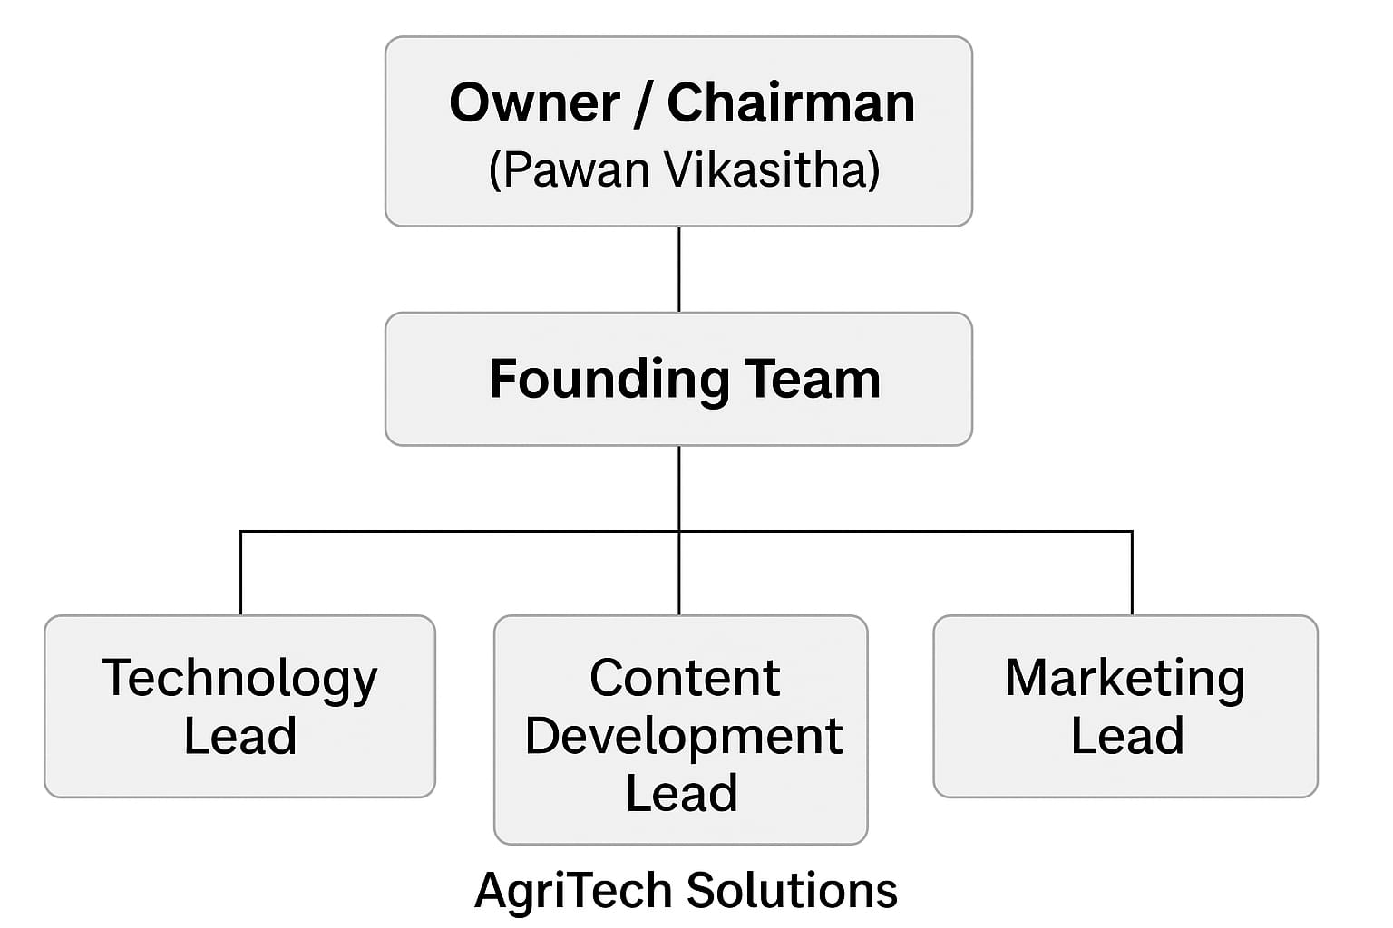

7. Operations Plan

7.1 General approach to operations
The platform operates entirely online, with a mobile app and website providing real-time advice, notifications and interactive sessions. The operations focus is on technical efficiency, content quality, and a user-friendly interface.

7.2 Business location
Headquarters are located in Anuradhapura, and the platform is designed for nationwide online access.

7.3 Facilities and equipment
Operations will include office computers, high-speed internet, software for app and website maintenance, cloud storage and servers for data management.

8. Product Design and Development Plan

Development Status and Tasks

1.Platform Development

Stage 1: In the initial stage, the basic capabilities of the platform (user registration, data storage, real-time update system) are created. At this stage, an easy-to-use user interface is developed for farmers.
Stage 2: Next, an AI-based crop advisory feature will be added to the system. This allows for specific advice based on crop conditions.
Stage 3: The system is continuously updated with software upgrades, bug fixes, and performance improvements based on user feedback.

2.Mobile App Development

Stage 1: The app prototype is developed and basic features such as weather updates, pest alerts, and fertilizer recommendations are added.
Stage 2: The app is tested before being released to the Google Play Store and App Store. The design and navigation are designed to be easy for farmers to use.
Stage 3: Bug fixes, update releases, and security improvements are developed based on user feedback. A subscription system is also added to the app.

3. Website and Data Integration

Stage 1: The website is designed with a responsive design and provides farmers with online access to tutorials, market prices, and expert Q&A sessions.
Stage 2: A database is established and real-time data sharing between the app and the website is enabled. This helps to keep user data, crop details and market information in a single platform.
Stage 3: Add security systems (SSL, data encryption) and backup plans to ensure the system runs reliably. Provide account recovery and cloud storage to users.

4.Digital Learning and Advisory Content

Stage 1: Work with agriculture experts to develop video tutorials, blog posts and FAQs content.
Stage 2: Upload this content to the platform and provide farmers with information on relevant crops, pest infestations and fertilizer suggestions.
Stage 3: Increase user engagement by organizing online webinars and live Q&A sessions.

5.Testing and Maintenance

Stage 1: Technically test the platform and monitor user experience.
Stage 2: Develop a maintenance schedule and perform regular software updates and database cleaning.
Stage 3: Collect feedback from users and continuously improve the system.

8.2 Challenges and risks

Some challenges and risks may be encountered during the implementation of the AgriTech Solutions business. One of the main challenges is the lack of understanding of technology among farmers. Many farmers do not have the necessary knowledge and confidence to use mobile applications or websites, which is a challenge in the first phase of the business.
Another risk is the low internet connection and lack of digital infrastructure in rural areas. Due to this, users may find it difficult to connect to real-time updates and video content. In such cases, it is essential to prepare an offline mode or lightweight version.
The emergence of new competitor platforms is another risk. In response, AgriTech Solutions is constantly adding new features, updating content, and improving user satisfaction to maintain competitiveness.
Finally, the challenges of data protection and cyber security must also be considered. Strong encryption systems and regular security audits are expected to be used to protect farmers’ data and market information.
  - Intellectual property

All creations, software codes, designs, content, and visual material of AgriTech Solutions are under the intellectual property rights of the company. The technical components of the mobile app, such as the source code, database structure, and AI-based crop advisory algorithm, are protected by copyright and software licenses.
Website content, blog posts, video tutorials, expert-written articles, and webinars are also considered intellectual property. Creative commons licenses and content watermarking technology are used to protect them from unauthorized copying or redistribution.
The name, logo and slogan of AgriTech Solutions will be registered as a trade mark of the business. This will protect the brand identity, and provide trust and legal protection in future partnerships or expansions.

9. Financial Projections

9.1 Sources and Uses of Funds Statement

The following table outlines the expected sources and uses of funds for AgriTech Solutions over the next three years.
Description | Year 1 (LKR) | Year 2 (LKR) | Year 3 (LKR)
Equity Capital | 3,000,000 | 1,500,000 | 0
Revenue | 2,400,000 | 4,500,000 | 7,500,000
Operating Expenses | 1,800,000 | 2,700,000 | 3,600,000
Marketing& Promotion | 600,000 | 900,000 | 1,200,000

9.2 Assumptions Sheet

- The online platform will gain approximately 1,000 users in the first year, 2,000 in the second, and 3,500 in the third year.
- Subscription fees are set at LKR 3,000 per user annually.
- Operational expenses increase by 20% annually.
- Marketing costs are expected to grow moderately by 15% each year.
- Taxes are estimated at 10% of net income.

9.3 Pro Forma Income Statement

Item | Year 1 | Year 2 | Year 3
Revenue | 2,400,000 | 4,500,000 | 7,500,000
Operating Expenses | 1,800,000 | 2,700,000 | 3,600,000
Marketing Expenses | 600,000 | 900,000 | 1,200,000
Net Profit Before Tax | 0 | 900,000 | 2,700,000
Net Profit After Tax (10%) | 0 | 810,000 | 2,430,000

9.4 Pro Forma Balance Sheet

Assets / Liabilities | Year 1 | Year 2 | Year 3
Cash & Bank | 1,200,000 | 2,100,000 | 3,600,000
Equipment | 1,500,000 | 1,500,000 | 1,500,000
Total Assets | 2,700,000 | 3,600,000 | 5,100,000
Liabilities | 600,000 | 900,000 | 1,200,000
Owner’s Equity | 2,100,000 | 2,700,000 | 3,900,000

9.5 Pro Forma Cash Flow Statement

Cash Flow Items | Year 1 | Year 2 | Year 3
Cash Inflow (Revenue) | 2,400,000 | 4,500,000 | 7,500,000
Cash Outflow (Expenses) | 2,100,000 | 3,600,000 | 4,800,000
Net Cash Flow | 300,000 | 900,000 | 2,700,000
Closing Cash Balance | 1,500,000 | 2,400,000 | 4,200,000

9.6 Ratio Analysis

- Average Rate of Return (ARR)
$$Average Net Profit = \frac{300,000+900,000+2,700,000}{3} = 1,300,000LKR$$
$$AAR = \frac{Average Net Profit}{Initial Investment} ×100\% = \frac{1,300,000}{3,000,000} ×100\% =43.33\%$$

- Net Present Value (NPV)

Assumptions
- Initial investment: 3,000,000 LKR
- Discount rate: 5%
- Year 1: 300,000LKR
- Year 2: 900,000 LKR
- Year 3: 2,700,000 LKR

$$NPV= \frac{300,000 }{{\left(1+0.05\right)}^{1}}+\frac{900,000 }{{\left(1+0.05\right)}^{2}}+\frac{2,700,000 }{{\left(1+0.05\right)}^{3}}-3,000,000$$
$$NPV= 3,434,915- 3,000,000$$
$$NPV= 434,915LKR$$

- Payback Period
$$Average Annual Cash Inflow = \frac{300,000+900,000+2,700,000}{3} = 1,300,000LKR$$
$$Payback Period = \frac{3,000,000}{1,300,000} = 2.31Years$$

- Current Ratio
$$Current Ratio = \frac{Current Assest}{Current Liabilities}$$
$$Year 1 = \frac{1,500,000}{600,000} =2.5$$

$$Year 2 = \frac{2,400,000}{900,000}=2.67$$

$$Year 3 = \frac{4,200,000}{1,200,000} =3.5$$

- Debt-to-Equity Ratio

$$Debt-to-Equity = \frac{Total Liabilities}{Owners Equity}$$

$$Year 1 = \frac{600,000}{2,400,000} =0.25$$

$$Year 2 = \frac{900,000}{3,000,000} =0.30$$

$$Year 3= \frac{1,200,000}{4,500,000} =0.27$$

